Sample Student Instructional Project: Appendix 3.c.
Name:_______________________________
Hot Dogs Sweetened by the Sun
Your goal is to construct a hot dog BBQ that can fully cook a hot dog using only the sun and the mathematics of parabolas. Whichever group cooks the best hot dog wins a prize!!!!
1) Let’s check out: Parabolas in Geogebra.
What important point of a parabola should the hot dog be placed upon?_________________________
2) What happens to the “a” as the distance from the vertex to the focus (F) gets bigger? _____________
3) Set F = .125 . What is the equation of the parabola? __________________ What is a? ___________
- What would be some real world advantages to having a hotdog cooker set up to this equation?

- What would be some real world disadvantages to having a hotdog cooker set up to this equation?

4) Set F = 7 . What is the equation of the parabola? __________________ What is a? ___________
- What would be some real world advantages to having a hotdog cooker set up to this equation?

- What would be some real world disadvantages to having a hotdog cooker set up to this equation?

5) Feel free to play with F at the board. Imagine that each unit represented 1 inch. What value of F do you think is best? F = ___________ Solve for “a” using the formula F = 1/4a . Confirm using Geogebra.

6) What is the equation of your model? ___________________________

7) Now it is time to construct the model. Here is a way that you can use the list feature to help with the calculations. Note: this is done for the equation y = 2x².
Let List 1 = Inches of the x-axis Define List 2 = Inches of the y-axis Hit Enter
Put cursor all the way on top.
y = 2x²
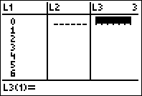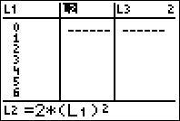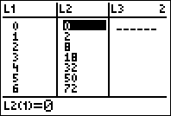
You now have the points for your model. Make a scale model below which includes: Points on parabola, location of Focus, location of Vertex, equation of parabola, distance to focus.
Scale: each box = 1 inch

8) Now build the real thing!
- Use the yard stick to grid out the materials
- Decide how wide it should be
- Figure out how you will secure the skewers and the hot dog
- Decide how you will strengthen the structure

